**Focus keyword**: Bloom Nutrition Greens

**Meta Title:** Bloom Nutrition Greens – vigoursoul

**Meta Description:** Bloom Nutrition Greens, you need to take vitamin C every day to maintain a strong immune system. You may easily get the nutrients your immune system needs drinking green juice.

**Feature Image:**

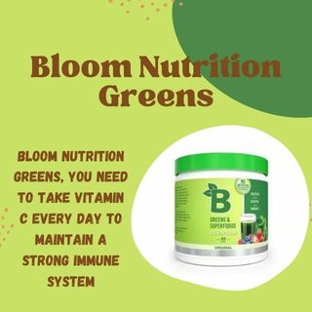

**Bloom Nutrition Greens**

**Bloom Nutrition Greens**, to keep your immunity healthy, you must take vitamin C every day. Getting the nutrients your immune system requires each day is simple if you drink a green juice.

You don't need to take **Bloom Nutrition Greens** at a specific time of day, with meals, or otherwise, because it contains everything you need for the greatest amount of nutrition. Feel free to take the dish whenever it is convenient for you because it contains all you need.

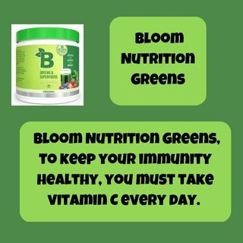

**Greens and Super Foods Bloom:**

**All-Natural Ingredients**

Our top priority is to develop a healthy product **Bloom Nutrition Greens** that is brimming with vital nutrients and organic super foods that give your body the nourishment it requires. Our premium greens powder is non-GMO, non-sugar, sugar-free, low carb, and vegan-certified.

**Clean Energy Boost:**

Our most popular Greens and Super food Essentials offer an eco-friendly method to increase your level of energy. Our **Bloom Nutrition Greens**, in contrast to most energy drinks, which contain sugar and caffeine, deliver long-lasting natural energy from matcha powder, garden fresh fruits, and veggies produced from sustainable farms.

**Promote Healthy Digesting:**

We've put together a delicious, nutrient-dense blend of raw superfoods that improves digestive health and helps with digestion. Our combination of digestive enzymes aids in breaking down the food you eat, and probiotics aid in the body's assimilation of those **Bloom Nutrition Greens**.

**Enhanced Immune Support:**

To aid in boosting immune response, our **Bloom Nutrition Greens** superfood powder contains a potent combination of vitamins, antioxidants, and adaptogenic herbs.

**Bloom Greens Ingredients:**

**Bloom Nutrition Greens is made up of following ingredients:**

With the exception of one, all of the elements in Bloom Nutrition Greens are found in proprietary blends totaling over 40. Proprietary blends aren't ideal since it's impossible to tell how much of each component is in the final product, which is terrible for brand transparency and consumer awareness.

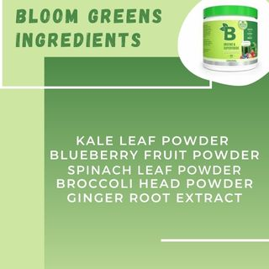

Inulin, Organic Flax Seed Powder, Apple Fruit Powder, Organic Barley Grass Powder, Organic Spirulina Powder, Organic Wheatgrass Powder, Organic Alfalfa Leaf Powder, Organic Chlorella Powder, Bifido bacteria Bifidum, Lactobacillus Rhamnosus, Lactobacillus Acidophilus, Organic Carrot Root Powder, Beet Root Powder, Kale Leaf Powder, Blueberry Fruit Powder, Spinach Leaf Powder, Broccoli Head Powder, Ginger Root Extract.

Cranberry Fruit Powder, Strawberry Fruit Powder, Raspberry Fruit Powder, Sour Cherry Fruit Extract, European Elder Fruit Powder, Cabbage Palm Fruit Extract, Lycium Fruit Powder, Moringa Leaf Powder, Grape Seed Extract, Matcha Green Tea Leaf Powder, Maltodextrin, Hemicellulase, Amylase, Protease, Xylanase, Cellulase, Lipase, Pectinase, Glucoamylase, Licorice Root Extract, Rhodiola Root Powder, American Ginseng Root Powder, Ashwagandha Root Powder, Astragalus Root Powder, Eleuthero Root Extract, Stevia Leaf Extract.

**Bloom Supplements Review:**

**Reviewed on November 21, 2022, in the United States**

I noticed that I wasn't getting nauseous at all after taking this. My family is large, so when one of us gets sick, we often all get sick. However, since I began taking this, I have never been ill. Even though my entire family was. Even when my family members were ill, I wouldn't get sick. All of that was a huge plus for me because prior to this, I frequently felt ill.

I discovered that I felt wonderful as well. I was more physically and psychologically energized after using **Bloom Nutrition Greens**. I had a lot of stomach problems prior to starting this, but it has also helped with those!

**Reviewed on November 22, 2022, in the United States**

Adore it I've been using it for two weeks and can't spend a day without it since it makes me feel so healthy and energized. Making a cup of **Bloom Nutrition Greens** is my favorite part of returning from the workout each morning! It will undoubtedly purge you and assist you in all the ways it claims. But be warned, it does taste a lot like tea, so if you don't like tea, you might not find it to be as delicious as I do.

**Reviewed on November 23, 2022, in the United States**

I kept seeing reviews of this item on tiktok, so I gave in at last. Every **Bloom Nutrition Greens** product I have tried has been less than exciting, despite everyone's insistence that these greens genuinely tasted wonderful. I adore this kind. I enjoy my mornings with greens and willingly drink it more than once. The fact that there are no chunks left after giving it a quick stir with a spoon also surprises me. Highly recommended 10/10.

**Advantages Bloom Nutrition Offer**

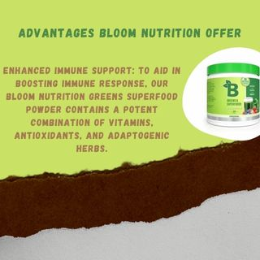

* Our combination of digestive enzymes aids in breaking down the food you eat, and probiotics aid in the body's assimilation of those nutrients.
* Enhanced Immune Support: To aid in boosting immune response, our **Bloom Nutrition Greens** superfood powder contains a potent combination of vitamins, antioxidants, and adaptogenic herbs.
* Intestinal health, immune function, and bloating are the three key areas that Bloom Nutrition Greens is designed to focus on.  
  A stronger immune system, less bloating, an increase in energy, and better gut health are all said to be benefits of taking the formula daily, according to the product's manufacturer.
* The brand does not, however, provide any additional information regarding any additional benefits or make any links between any particular ingredients and the claimed health benefits, except from those mentioned above.
* It is unfortunate because there should be a large list of advantages to the mix if the chemicals are dosed properly.

**Bloom Nutrition Greens- FAQS**

**Has sugar been added to Bloom nutrition?**

Our premium greens powder is non-GMO, non-sugar, sugar-free, low carb, and vegan-certified.

**How begin of Bloom Nutrition?**

Mari Llewellyn, CEO, mental health advocate, and fitness entrepreneur, founded Bloom in 2019 after realizing that none of the **Bloom Nutrition Greens** supplements on the market at the time satisfied her requirements for good taste and pure ingredients.

**How long does Bloom Booster take to start working?**

Immediately feeding causes plants to grow larger and more attractively than unfed plants. Every 1-2 weeks, feed. Developed with a lot of phosphorus to increase bloom production and color. Instantly gets to work to produce beautiful, quick results.

**Is Bloom nourishment made from plants?**

It is a real vegan protein that is highly bio available, digestible, and provides a high level of functionality and nutritional advantages. Additionally, this product contains special combinations of fruits, vegetables, and greens.

**Does Bloom Super greens aid in weight loss?**

Your weight loss efforts may benefit from eating super **Bloom Nutrition Greens** because of the high fibre content. Fiber stimulates our metabolism, which is essential for burning some of the extra fat and keeping a lean body.

**Does consuming greens aid in reducing bloating?**

However, thanks to those helpful digestive enzymes from super greens powder that we previously discussed, your gut can handle circumstances that would typically result in bloating much more easily. Overall, this lessens bloating.

**Does Bloom Nutrition work?**

The bloom effect is used to mimic an imaging artefact found in actual cameras. The effect creates light fringes that extend from the edges of bright areas in an image, adding to the impression that the scene is being captured by a camera or eye that is being overwhelmed by an extremely bright light.

**Conclusion**

Our **Bloom Nutrition Greens** is combination of digestive enzymes aids in breaking down the food you eat, and probiotics aid in the body's assimilation of those nutrients. Enhanced immune support to aid in boosting immune response.

The bloom effect is used to mimic an image art fact found in actual cameras. The effect **Bloom Nutrition Greens** creates light fringes that extend from the edges of bright spots in a picture, adding to the impression that the scene is being captured by a camera or eye that is being overwhelmed by an incredibly intense light.